234.2

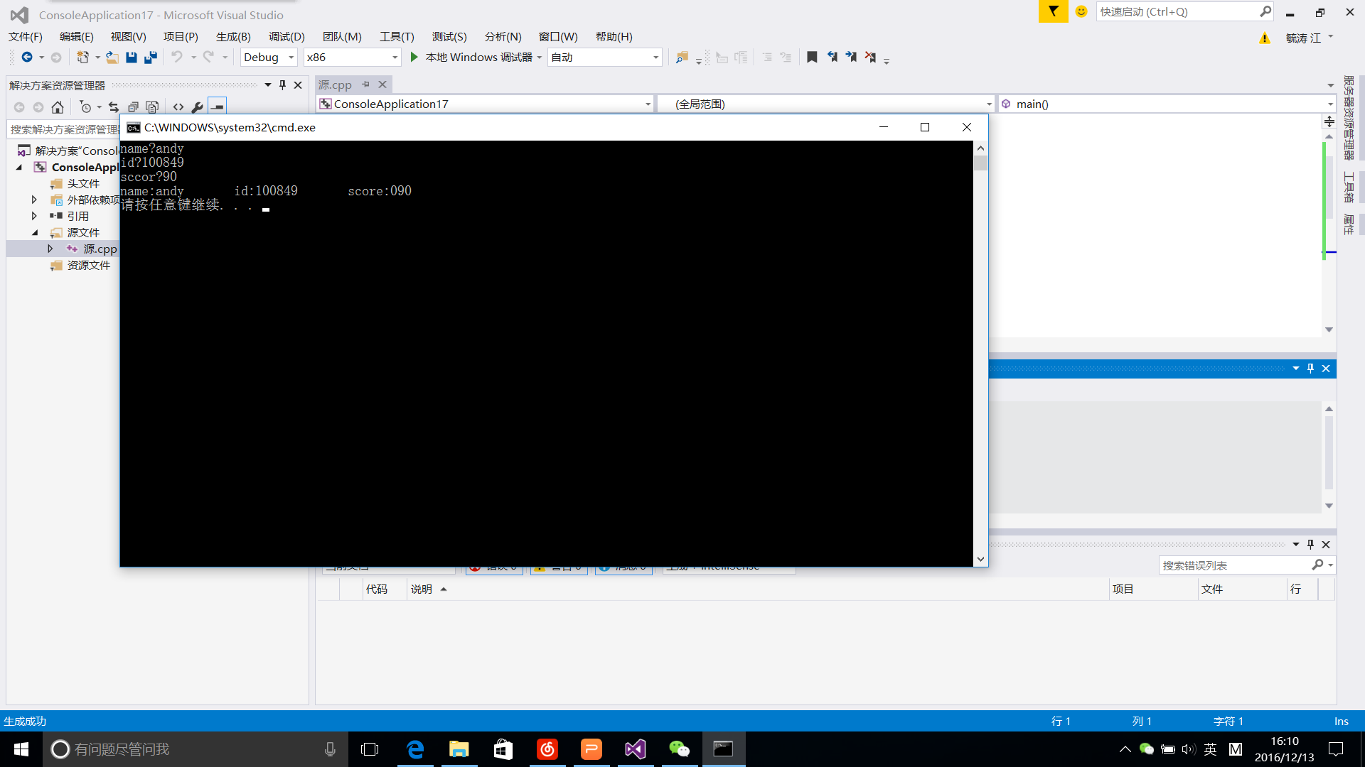

#include <iostream>

using namespace std;

struct student

{

char name[20];

unsigned int id;

double score;

void input(student &stu);

void output(student &stu);

};

void student::input(student &stu)

{

cout << "name?";

cin >> stu.name;

cout << "id?";

cin >> stu.id;

cout << "sccor?";

cin >> stu.score;

}

void student::output(student &stu)

{

cout << "name:" << stu.name << "\tid:" << stu.id << "\tscore:0" << stu.score << endl;

}

int main()

{

student s = { "\0",0,0 };

s.input(s);s.output(s);

}

242.1

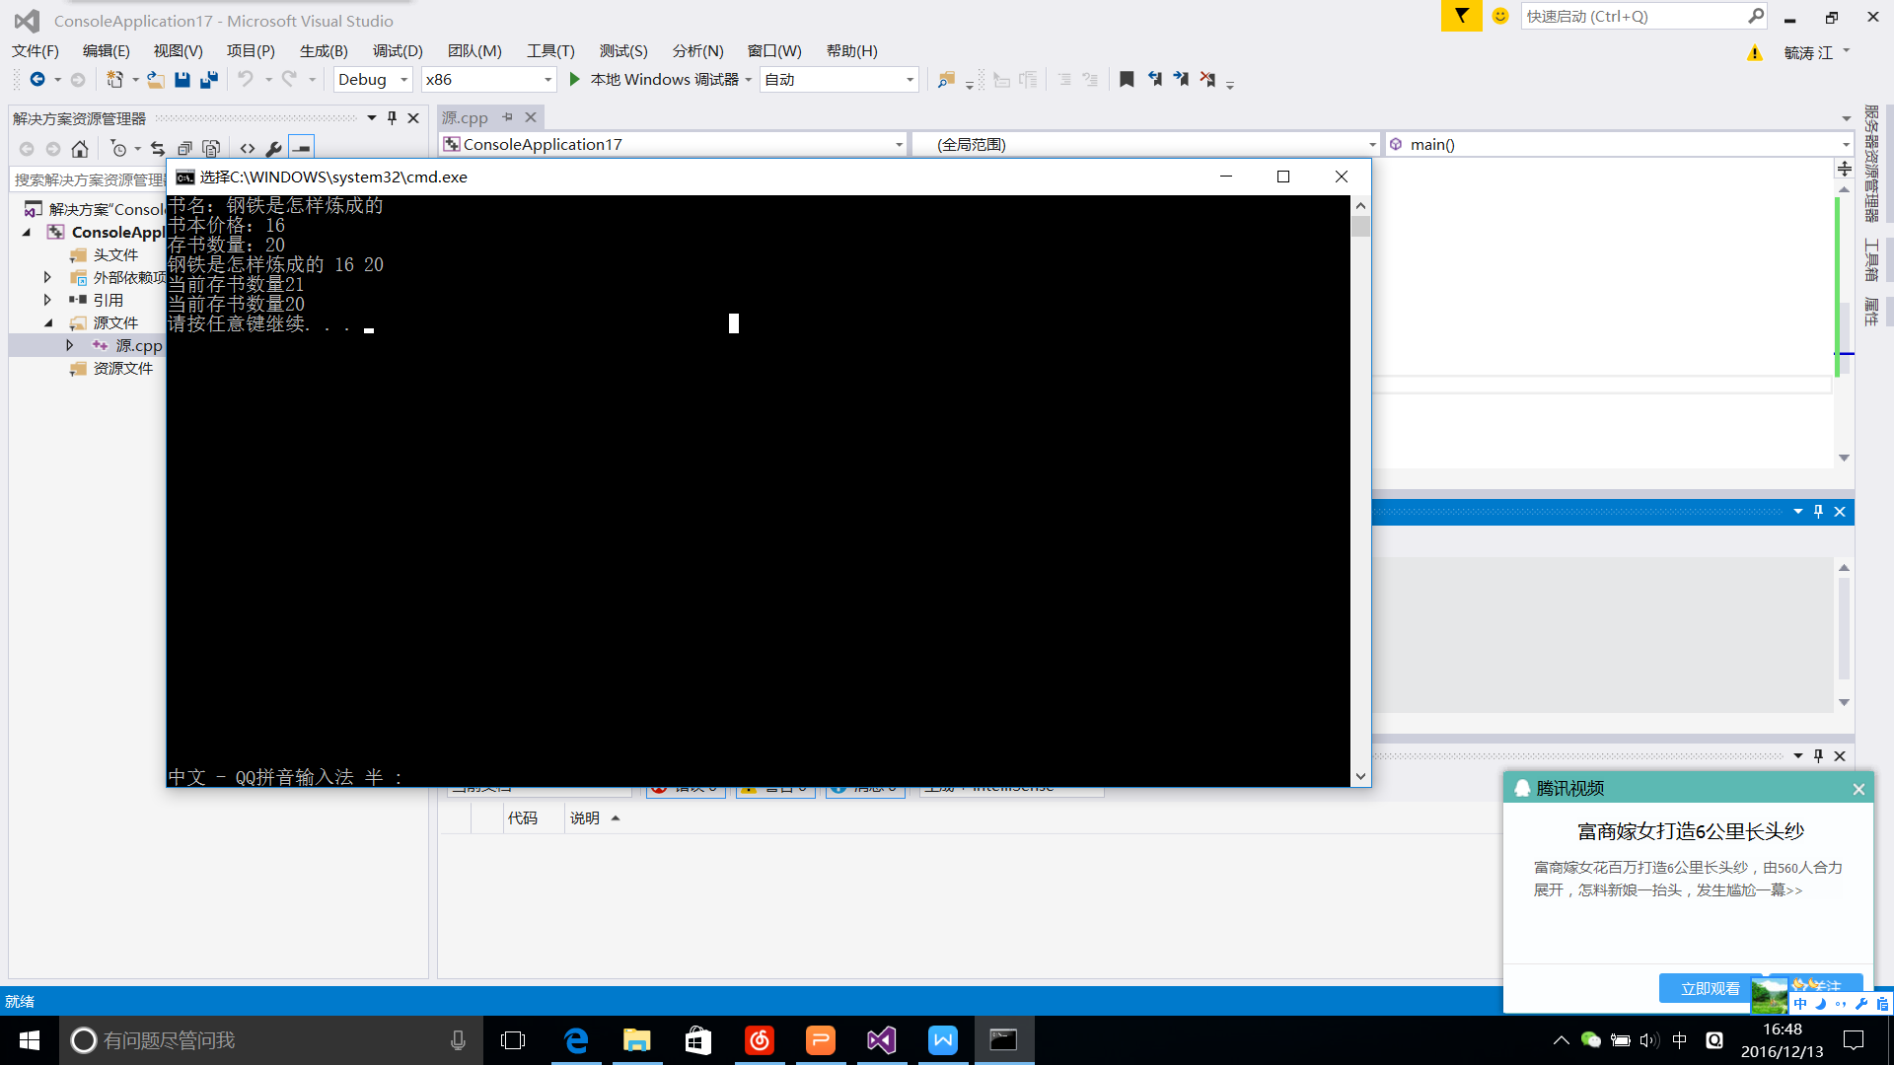#include <iostream>

using namespace std;

class Book

{

public:

char bookname[30];

double price;

int number;

void display(Book a);

void restore(Book a);

void borrow(Book a);

};

void Book::display(Book a)

{

cout << bookname << " " << price << " " << number << endl;

}

void Book::restore(Book a)

{

number++;cout << "当前存书数量" << number << endl;

}

void Book::borrow(Book a)

{

number--;cout << "当前存书数量" << number << endl;

}

int main()

{

Book b;

cout << "书名：";

cin >> b.bookname;

cout << "书本价格：";

cin >> b.price;

cout << "存书数量：";

cin >> b.number;

b.display(b);

b.restore(b);

b.borrow(b);

}

242.3

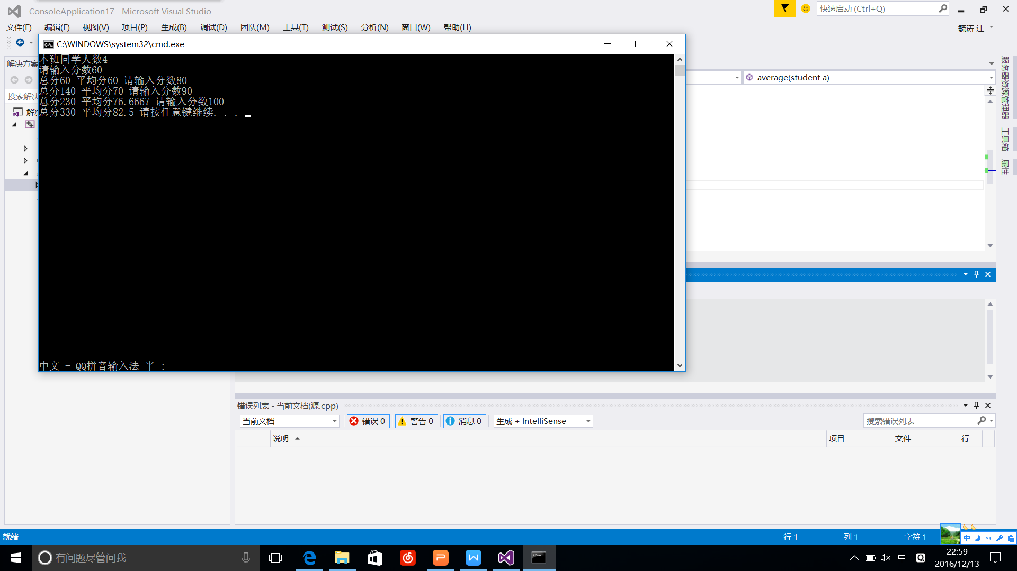#include <iostream>

using namespace std;

class student

{public:

student() {};

double score;

static int count;

static double total;

void scoretotalcount(student a);

static void sum(student a);

static void average(student a);

};

double student::total = 0;

void student::scoretotalcount(student a)

{

cout << "请输入分数";

cin >> score;

count++;

total += score;

}

void student::sum(student a )

{

cout << "总分" << total<<" ";

}

void student::average(student a)

{

double b;

b = total/count;

cout <<"平均分"<< b<<" ";

}

int student::count = 0;

int main()

{

int c;

cout << "本班同学人数";

cin >> c;

for (int i = 1;i <= c;i++)

{

student c;

c.scoretotalcount(c);

c.sum(c);c.average(c);

}

}